**ERD Submission – Group C5**

**Group members:**

1. Daniel Tilley – C14337041
2. Behzad Sanehi – C14558463

**Case Study:**

Student Residence

**Our ERD:**

From the case study, we have determined there are 2 main actors which are Porter and Student. We have decided to divide up the tasks based on these main actors taking one each. Below is a screen shot of our ERD.

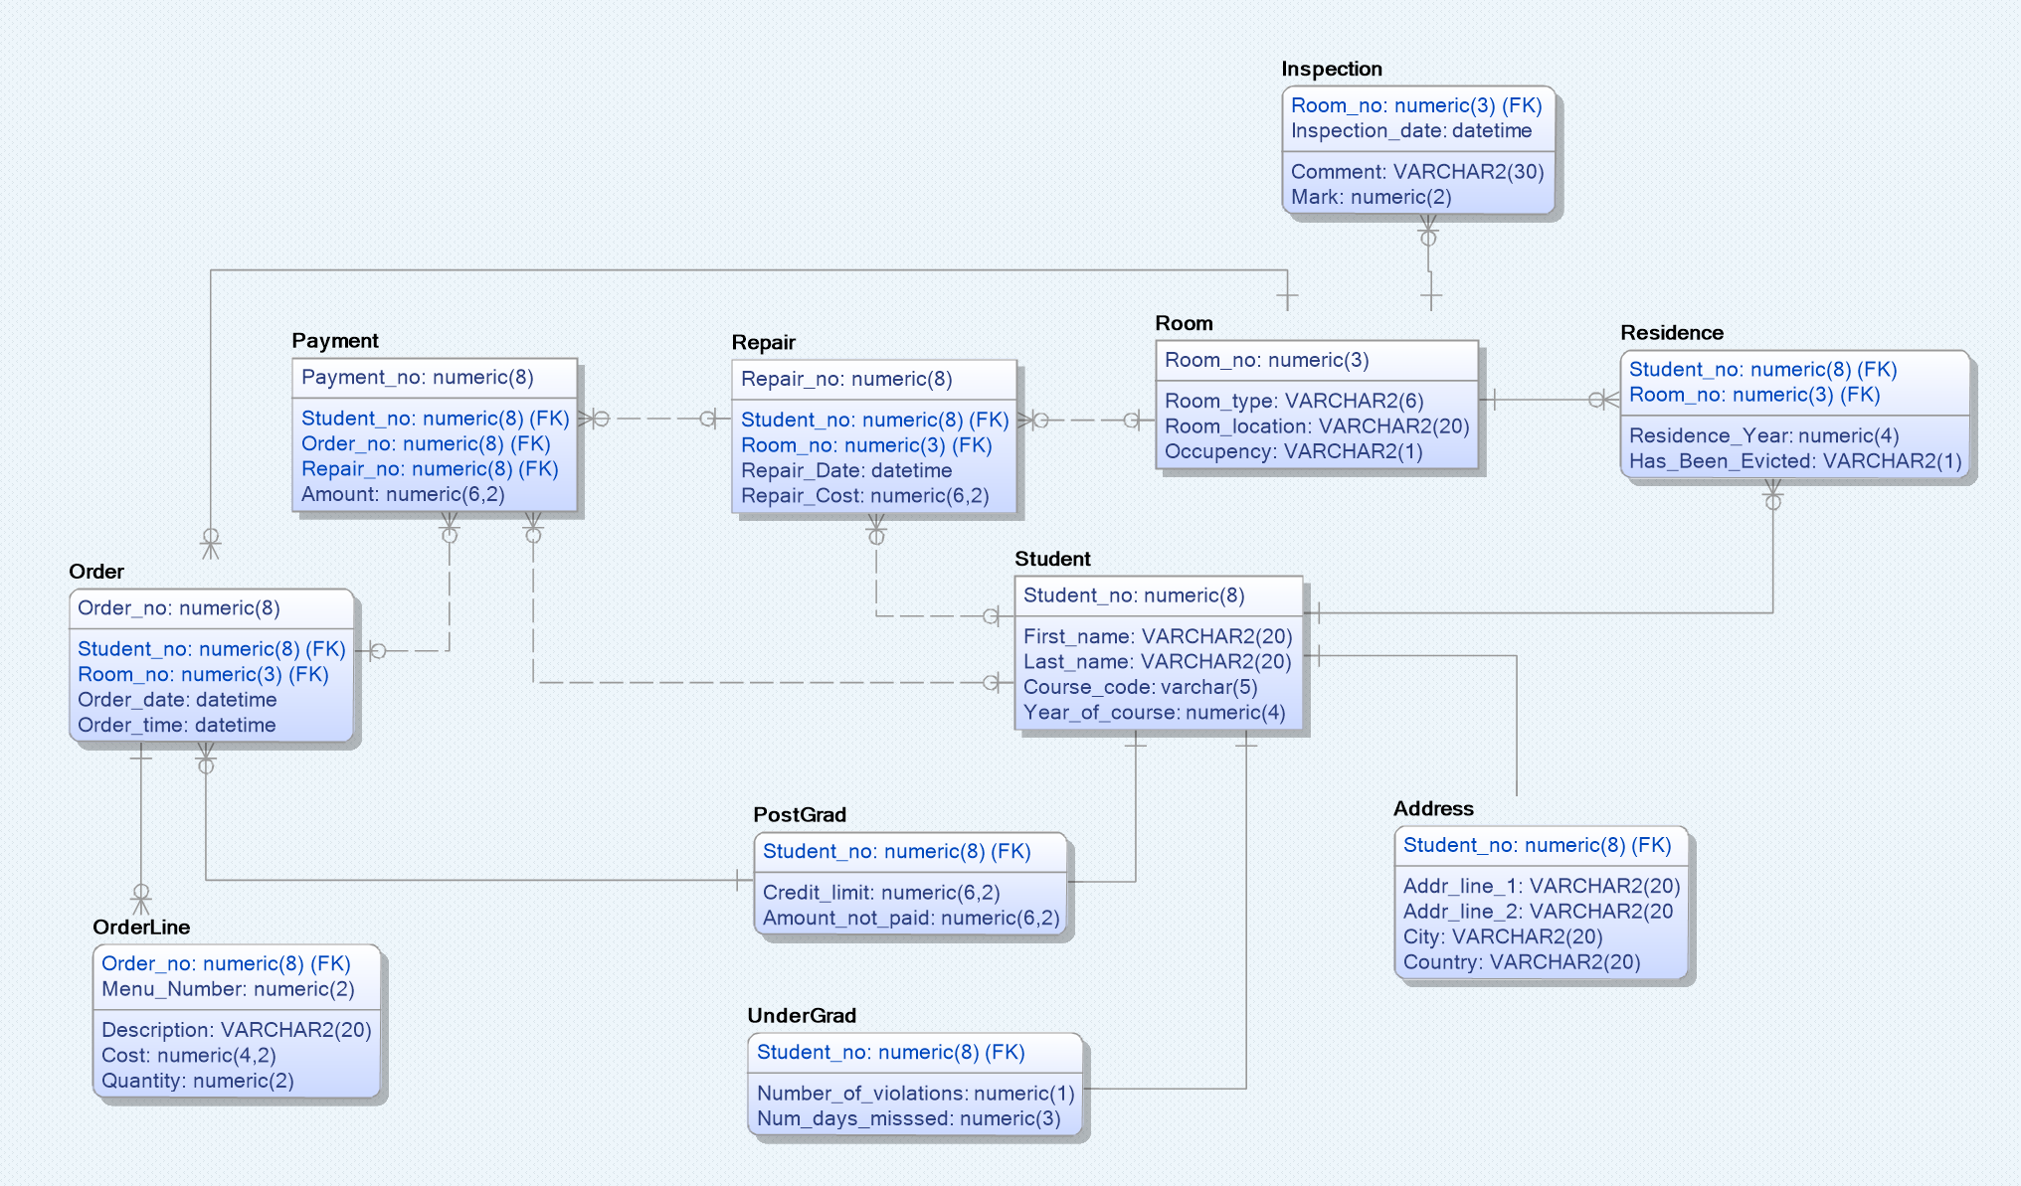

**Functionality Implementation:**

Daniel: created the ERD using a use case diagram and normalistation. Daniel will be in charge of the Student actor in the implementation. He will manage things such as making paymemts, ordering food and drink, looking for a free room etc. Daniel will perform mostly selects and updates, but will still use creates.

Behzad: produced a use case diagram to make it easier for Daniel to design an ERD. Behzad will be in charge of the Porter actor in the implementation. He will manage things such as recording students, allocating rooms, recording damage etc. Behzad will mostly perform creates and updates, but will still use selects.

**Privilages required:**

Daniel: will need access to sequences (create, alter and delete), creates, updates, deletes, constraints, sessions and tablespace. He will be in charge of creating and maintaining things such as order number sequences and order tables, but will also work with Behzad on tables such as inspection, room and payment doing things such as selects and updates.

Behzad: will need access to sequences (create, alter and delete), creates, updates, deletes, constraints, sessions and tablespace. He will be in charge of creating and maintaining sequences such as room number, student number, repair number etc. and tables such as room, student, residence etc., but will also work with Daniel on tables such as inspection, room and payment doing things such as selects and updates.

**How will work help / conflict?:**

As there is a lot of overlap between both Daniel and Behzad, they will need yo co-operate very efficently and effectivley in order to achieve a shared end goal of implementing the syetem.

Daniel: will have to make sure all his tables are created and ready to use before applying constraints such as foreign keys and primary keys. Once his tables have been created, he can work on implementing keys (he must wait for Behzad to create parent keys in the room and student tables). Once doing the inserts, Daniel will have to get all relevant key data from Behzad such as student number and room number (so not to cause duplication or conflict). It will also be important that when Daniel does any updates that he informs Behzad so as to avoid duplication or mismatching data in tables.

Behzad: will have to make sure all his tables are created and ready to use before applying constraints such as foreign keys and primary keys. Behzad should have no problem implementing his constarints as he is in charge of tables that contain parent keys. Behzad must then communicate with Daniel to ensure that when he is running his inserts that any key data matches what Daniel will eneter into his such as room number, student number etc. It will also be important that when Behzad does any updates that he informs Daniel so as to avoid duplication or mismatching data in tables